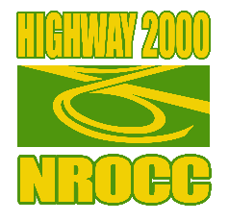

**WATER TRUCKS NEEDED**….

to provide dust mitigation in the following areas:

* Denbigh Road, Clarendon
* Redberry Road, Manchester

Service will be required from January 2021 to October 2022.

Interested persons should send proposals by December 31, 2020 via email to:

[georgenicholson@h2kjamaica.com.jm](mailto:georgenicholson@h2kjamaica.com.jm)